**GIS**

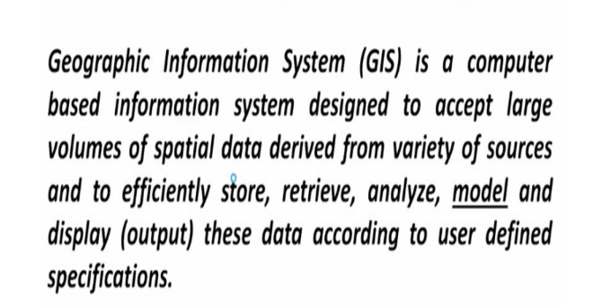

geographic location==>give in terms of latitude, longitude-->in GIS, we use geographic coordinate system.

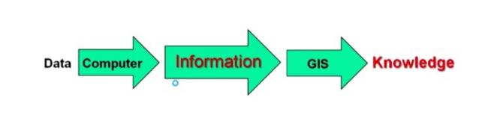

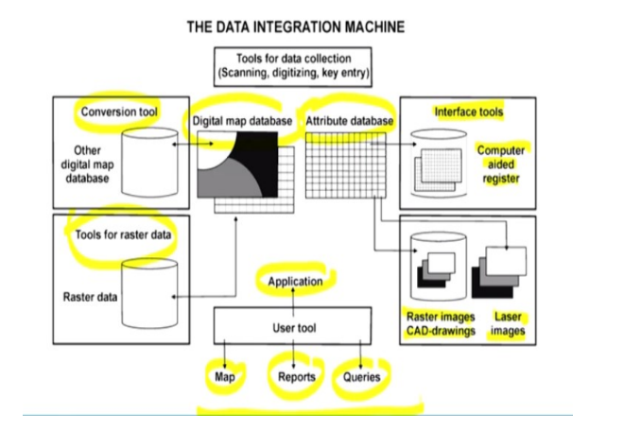

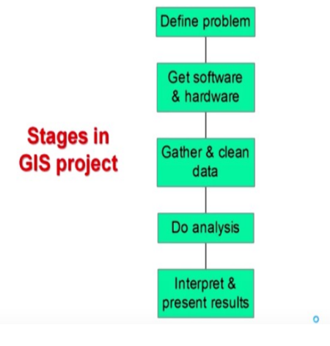

Paer2

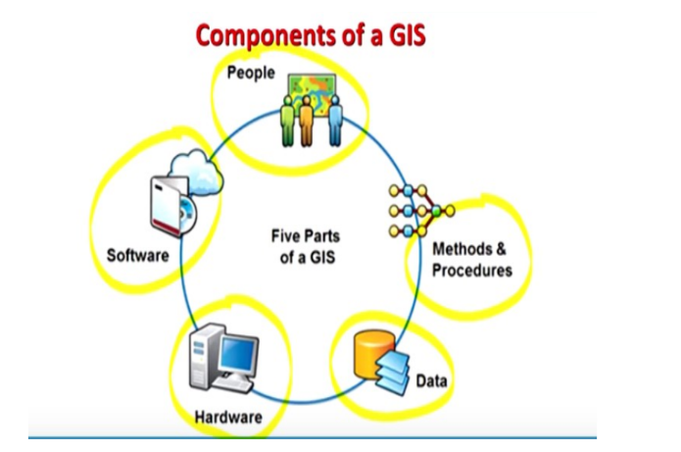

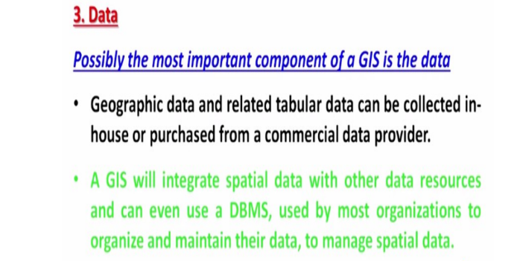

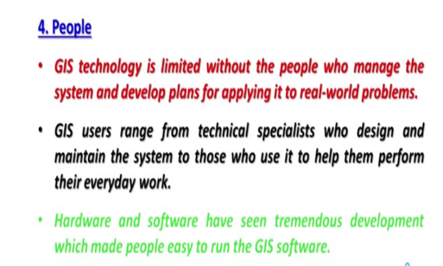

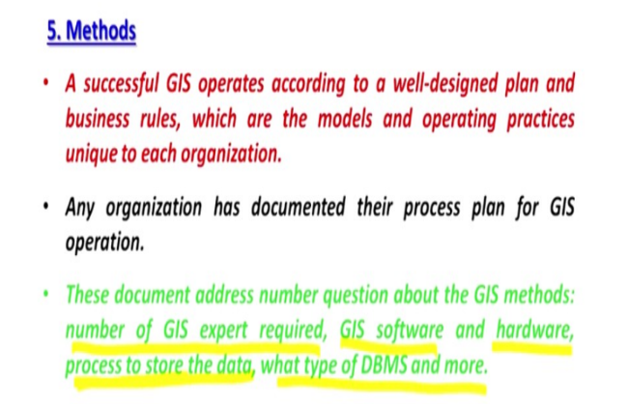

Spatial data==>which is having its geographic location-->will have its own location of the data.

GIS is a computer based information system designed to accept large volumes of spatial

data so that variety of data can also come in large volume.

GNSS (Global Navigation Satellite Systems)receiver

GIS is the only unique

platform which handles spatial data; data which is having a geographic location. So, that data

can be used analysed and that data, we can transform into the information.

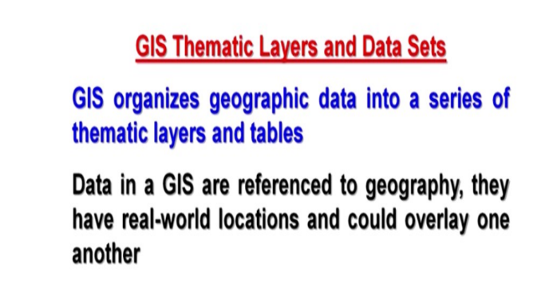

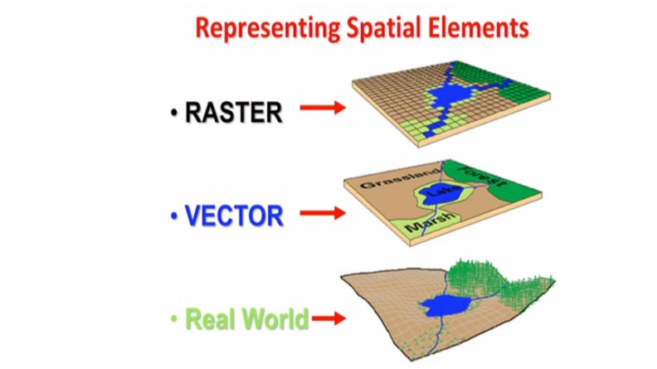

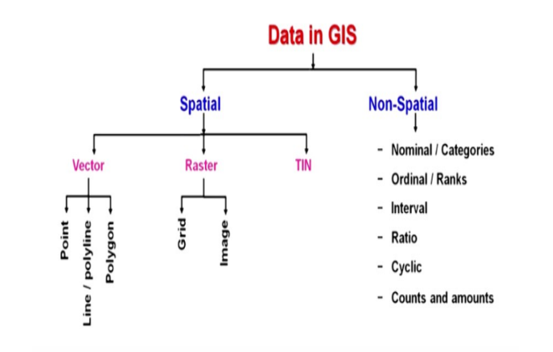

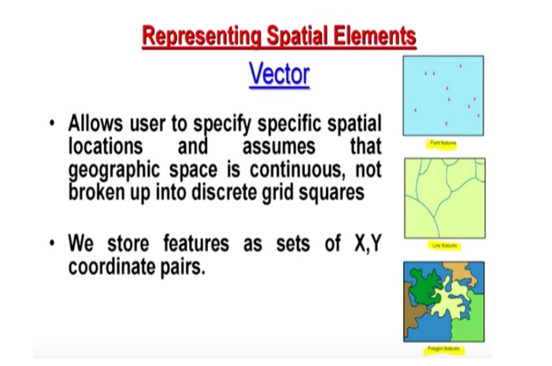

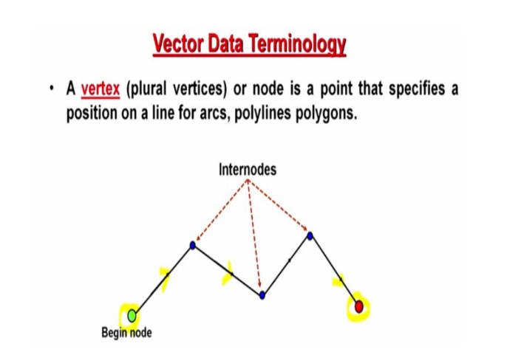

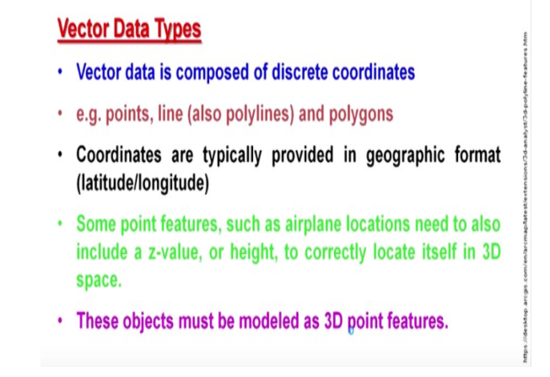

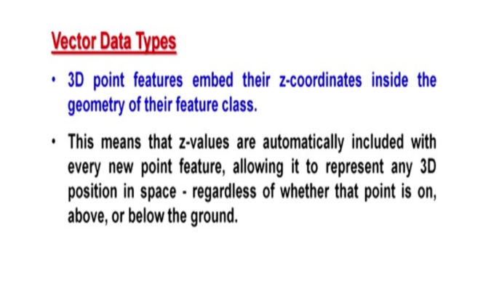

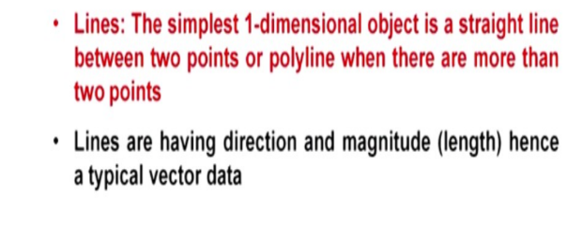

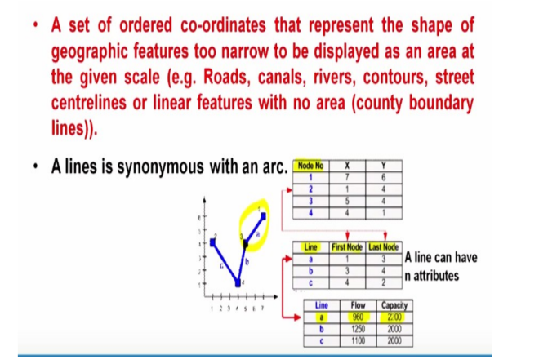

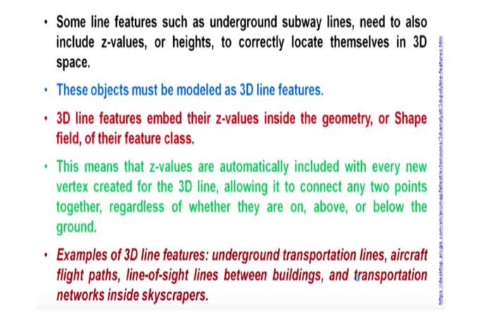

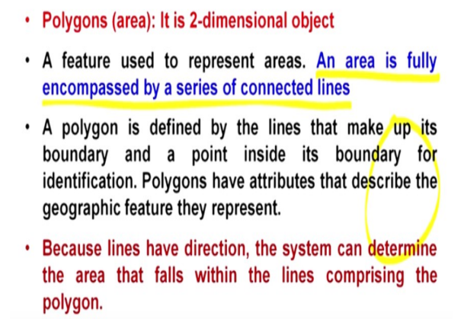

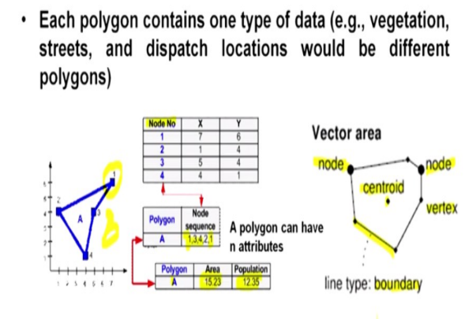

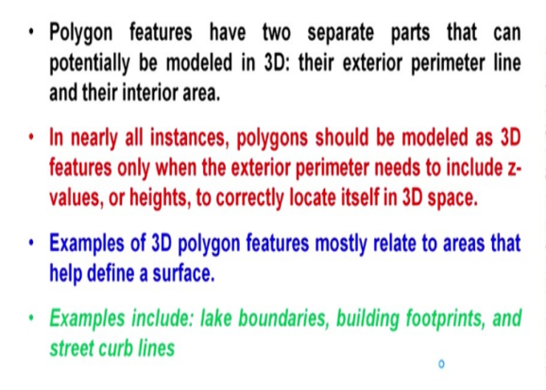

Digital elevation model==> which is that topographic surface of the earth

which is also stored on or which is also accessible through Google Earth. So, you get not only

the latitude, longitude but you also get the elevation; topographic height wherever you are

located on Google Earth.

The integration of remote sensing and the digital elevation model is part of GIS.

Satellite images are part of your remote sensing and location is also coming from GPS.

ArcGIS which is ESRI;Environmental Science Research Institute. It’s a private company; commercial product is nowadays called ArcGIS.

GRASS and QGIS

GIS be divided into 2 main categories initially:

one is the geographic data or spatial data.

Another one is also called non spatial data or tabular data or attribute data.

Spatial data means having geographic location.

grid and image are 2 different types of raster data.

spatial data includes vector data, raster data and TIN (Triangulated Irregular Network)data.

And your non spatial data is mainly the attribute data or tabular data and includes interval data, ratio data and cyclic data and last one is counts and amounts.

we call a vector data as discrete data or discontinuous whereas the raster data is continuous data.

TIN are triangles whereas in raster, units are square in shape that means cells or

pixels. So, if it is an image, we call as pixel. If it is a grid, we call as cell. So, the shape of the

cell is always square in shape whereas in case of TIN, the shape of unit is always triangle of

varying size and shapes. So, that is why it is called irregular network of triangles so,

triangulated irregular network whereas in vector all are controlled by the coordinates.

3D points that means the point is having X, Y and z value. But that z value will always be stored as in non spatial information.

z value, it has to be stored as a non spatial information in attribute table whether it is a height of

a plane or even depth of a well or any other information which requires a third dimension to

be stored, can be stored

GIS terminology whenever

we say straight line means it will have just 2 pairs of x and y. And whenever we say polyline

that means it is having more than 2 pairs of x and y.

a set of ordered

coordinates that represents the line or a shape or a feature; though it will not have width but it

will have only the line that is why it is called single dimensional entity.

Why it is 2

dimensional objects? Because for polygon, we can measure the area as well as the perimeter,

so that is why it is called.

3 basic entities; one is point which is the simple

zero dimensional entity, no measurements are possible. Only it stores X and Y coordinates. If

you want to store z coordinates, it will go as attribute value. Now line or polyline is a 1

dimensional entity. You are having begin point end point or a begin node, end node. And if it

is polyline then X1, Y1 and Xn, Yn and here you can definitely measure the length and of

course, the direction is also known.

Concept of Topology

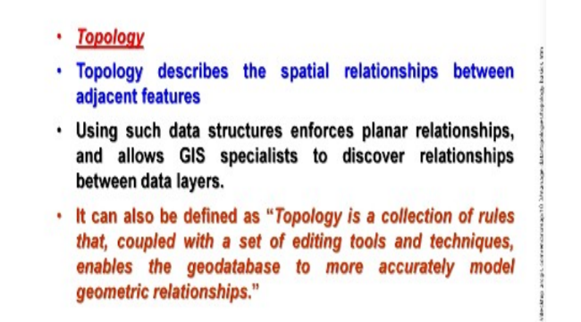

**Adjacent features** may be another polygon or different polygons around a polygon or maybe line

features or even point features.

For line or points; it is not difficult at all to develop a topology. So, for topology specifically, it is for **polygon** data.

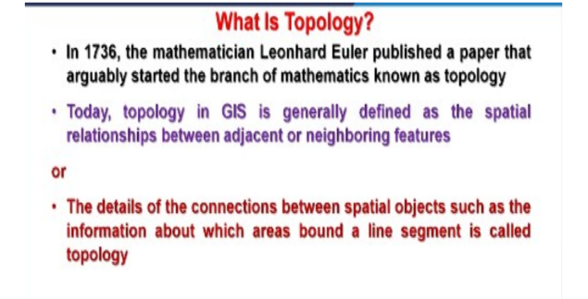

The details of connections between a spatial object such as information about which areas

bound a line segment is called **topology**.

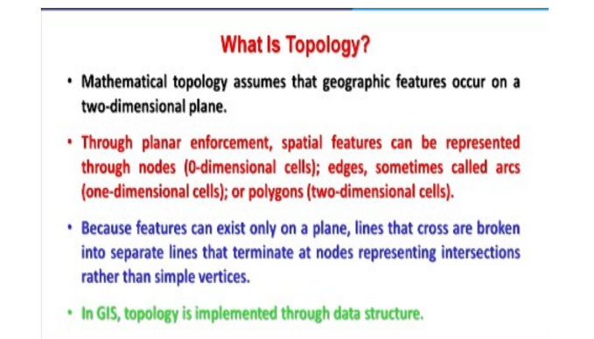

topology is built while digitizing process is going on simultaneously.

Error has to be corrected itself whenever first time it has been detected. So,

as soon as one realizes there is error, immediately should be corrected. Another advantage of

a topology buildup is; it loses the data storage because adjacent 2 polygons boundaries will

be stored only once that means that the common boundary between 2 polygons is stored once

if topology has been built.

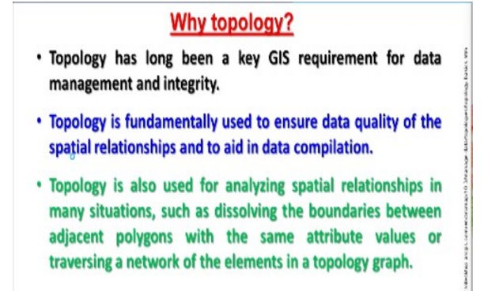

topology is used basically to ensure data quality because errors are minimized and to maintain the spatial relationship and it also aid in data compilation.

Topology is also used for analyzing spatial relationships in many situations such as

dissolving boundaries between adjacent polygons with the same attribute values or traversing

a network of elements in a topology graph.

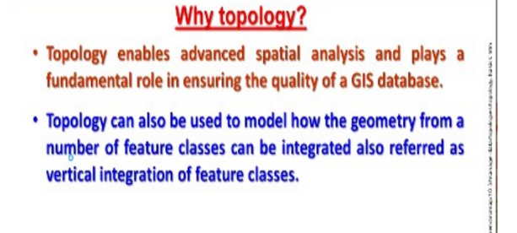

Topology is a collection of rules that, coupled with a set of editing tools and techniques, enable the geodatabase to more accurately model geometric relationships. ArcGIS implements topology through a set of rules that define how features may share a geographic space and a set of editing tools that work with features that share geometry in an integrated fashion. A topology is stored in a geodatabase as one or more relationships that define how the features in one or more feature classes share geometry. The features participating in a topology are still simple feature classes—rather than modifying the definition of the feature class, a topology serves as a description of how the features can be spatially related.

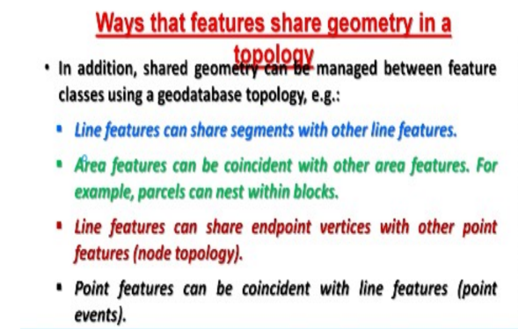

## Why topology?

Topology has long been a key GIS requirement for data management and integrity. In general, a topological data model manages spatial relationships by representing spatial objects (point, line, and area features) as an underlying graph of topological primitives—nodes, faces, and edges. These primitives, together with their relationships to one another and to the features whose boundaries they represent, are defined by representing the feature geometries in a planar graph of topological elements.

Topology is fundamentally used to ensure data quality of the spatial relationships and to aid in data compilation. Topology is also used for analyzing spatial relationships in many situations, such as dissolving the boundaries between adjacent polygons with the same attribute values or traversing a network of the elements in a topology graph.

Topology can also be used to model how the geometry from a number of feature classes can be integrated. Some refer to this as vertical integration of feature classes.

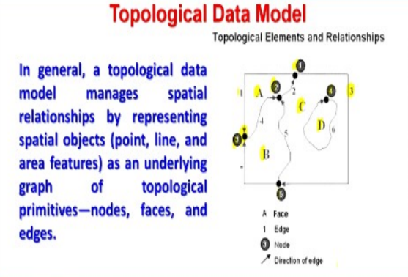

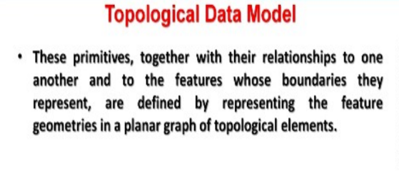

Lec 5

ArcGIS

**ArcGIS** is having 3 major components:

**ArcMap** where you make the display of the different layer’s data.

**Arc Catalog** provides a catalog window that is used to organize and manage various types of geographic information for ArcGIS Desktop.

**Arc toolbox** and it is having hundreds of tools organized under different categories.

Lec 6

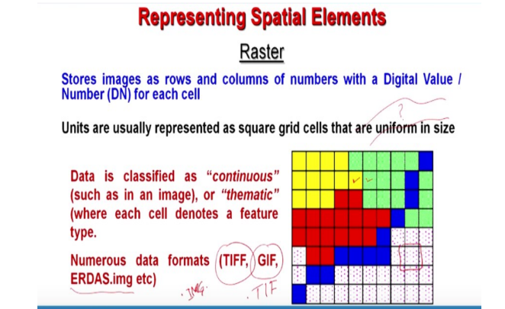

Raster in either square or reactangle

No other shape is allowed in raster data because each cell is representing a ground area and both x and y of cell is also same.

So if I say that though unit is in square in shape, however the overall shape of a raster can be

either a square or rectangular. But the unit has to be always **square**.

Raster data represent features as a matrix of cells within rows and columns in continuous space

These cells are of a specific dimension size

Each raster data layer represents one attribute (e.g. elevation)

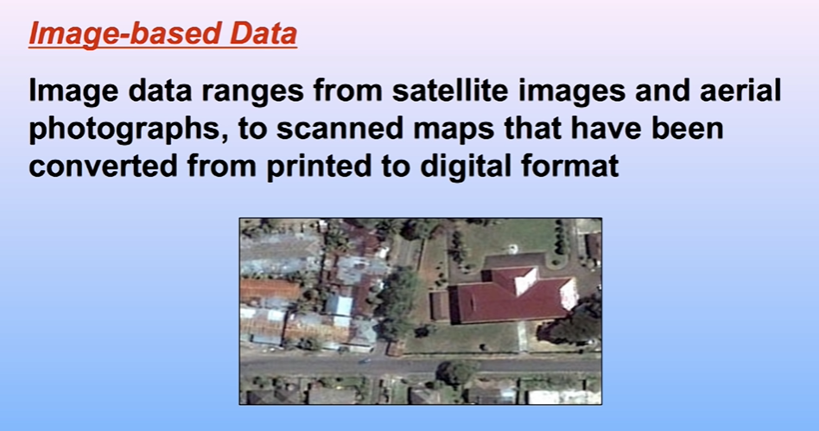

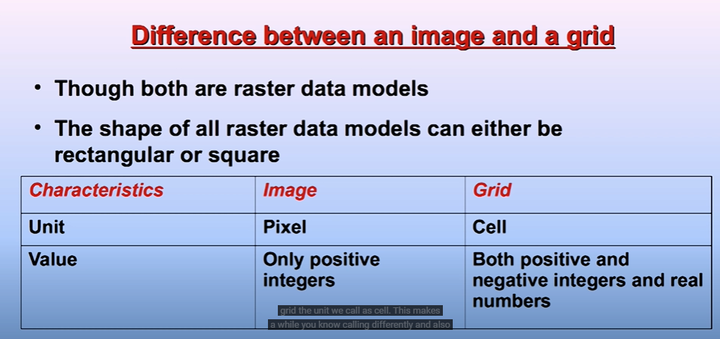

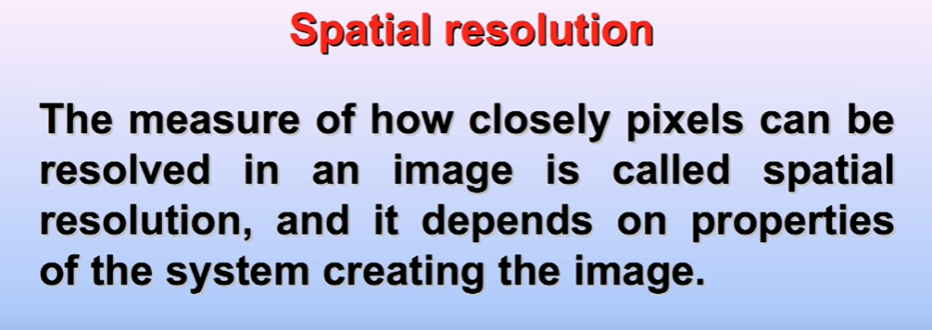



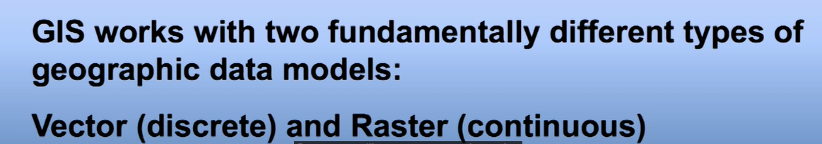

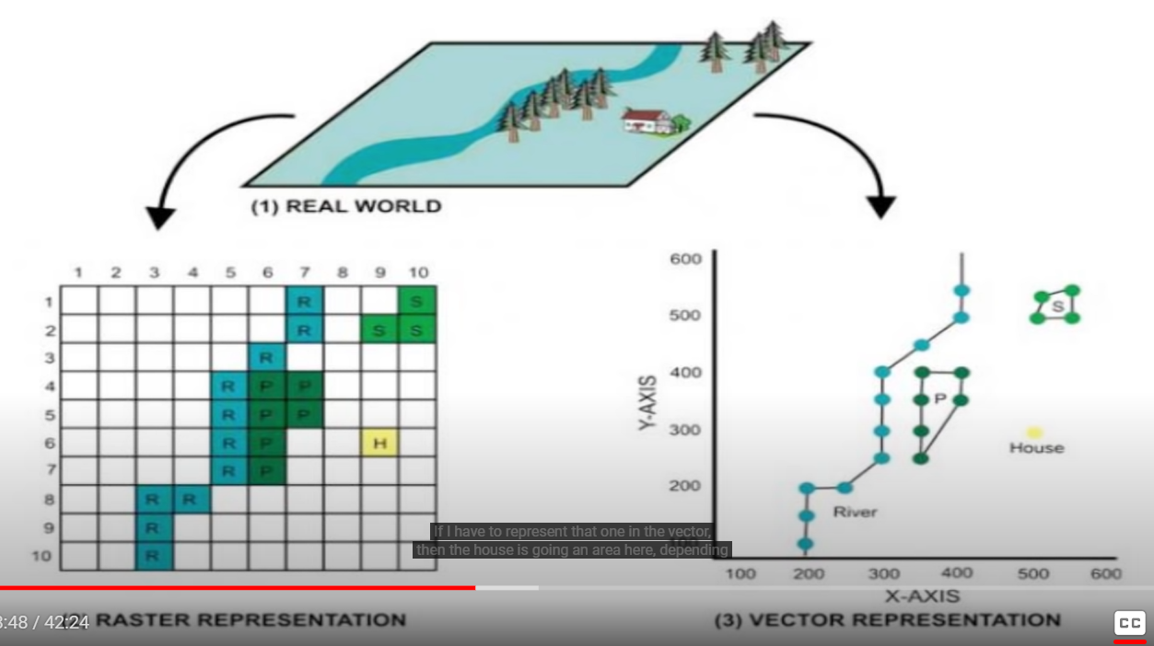

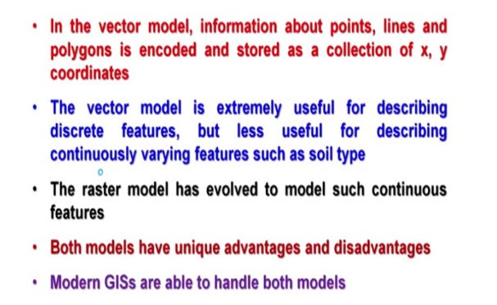

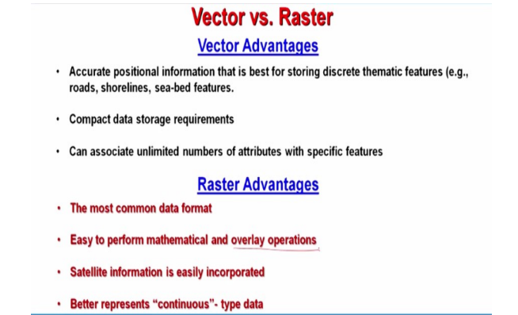

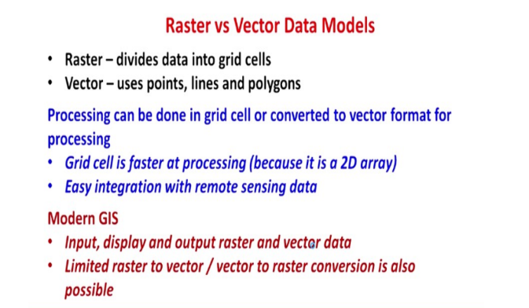

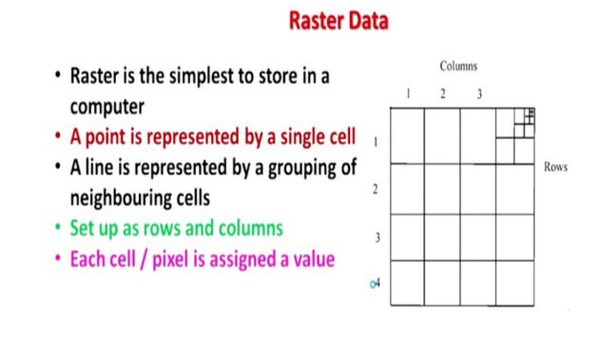

unit in case of vector can be point, line and polygon. But ultimate is the coordinate; x and y pair. But in case of grid or raster, you are having either cell or pixel as unit.

